**DESIGNING QRCODE USING PYTHON PROGRAMMING FOR FOOD PAGES**

## **A MINI PROJECT REPORT**

***Submitted by***

P.SHIVASHREE

R.SHRUTHI

S.R.VARSHINI PRIYA

In partial fulfilment for the award of the degree

of

# BACHELOR OF TECHNOLOGY

**IN**

**INFROMATION TECHNOLOGY**

**K.RAMAKRISHNAN COLLEGE OF ENGINEERING (AUTONOMOUS),**

**SAMAYAPURAM, TIRUCHIRAPPALLI -621 112**

# ANNA UNIVERSITY: CHENNAI 600 025

**MAY 2022**

**ANNA UNIVERSITY : CHENNAI 600 025**

# BONAFIDE CERTIFICATE

<Font Style Times New Roman – size -14>

Certified that this project report **“……….TITLE OF THE PROJECT……………..”** is the bonafide work of “**…………..NAME OF THE CANDIDATE(S).…………”** who carried out the project work under my supervision.

**SIGNATURE SIGNATURE**

**HEAD OF THE DEPARTMENT SUPERVISOR**

<<Academic Designation>>

<<Department>> <<Department>>

<<Full address of the Dept & College >> <<Full address of the Dept & College >>

**TABLE OF CONTENTS**

### **CHAPTER NO. TITLE PAGE NO**

**ACKNOWLEDGEMENT**

We thank the almighty GOD, without whom it would not have been possible for us to complete our project.

We wish to address our profound gratitude to **Dr. K. RAMAKRISHNAN**, Chairman, K. Ramakrishnan College of Engineering, who encouraged and gave us all help throughout the course.

We express our hearty gratitude and thanks to our honorable and grateful executive director **Dr. S. KUPPUSAMY, B.sc., MBA., Ph.D.,** K. Ramakrishnan College of Engineering.

We are glad to thank our principal **Dr. D. SRINIVASAN, M.E, Ph.D., FIE., MIIW., MISTE., MISAE., C.Engg.**, for giving us permission to carry out this project.

We wish to convey our sincere thanks to **Dr. S.MANIKANDAN Professor and** Head of the Department, Information Technology for giving us constant encouragement and advice throughout the course.

Finally we sincerely acknowledged in no less term for all our staff members, colleagues, our parents and friends for their co-operation and help at various stages of this project work.

**ABSTRACT**

In most of the restaurant meal ordering is relying on the interaction with waiters to place order into the kitchen. In busy hours of restaurant this coordination is a challenge result in un-satisfaction to the customer. This method uses modern innovation such as multi-touch module, RF module, Meal Serving Robot and database to improve quality of services of Restaurant and to enhance customers’ dining experience.

The website, which is the only component seen by the restaurant customers, is then built dynamically based on the current state of the system, so any changes made are reflected in real time. Visitors to the site, once registered, are then able to easily navigate this menu, add food items to their order, and specify delivery options with only a few clicks, greatly simplifying the ordering process. Back in the restaurant, placed orders are promptly retrieved and displayed in an easily readable format for efficient processing.

The system, which is highly customizable, allows the restaurant employees to easily manage the site content, most importantly the menu, themselves through a very intuitive graphical interface.

**CHAPTER-1**

**INTRODUCTION**

### **1.1 INTRODUCTION**

Now a days Digital multi-touch menu cards in restaurant are replacing traditional services where waiters take order from customer according to their menu requirement. In traditional restaurant orders are taken by waiters and they bring the food when it is ready later the customer pay the bill to the waiter or to the accountant at Reception area.

This system relies on large numbers of manpower to handle customer reservation, ordering food, placing order on table, reminding orders of customer and billing. Therefore, how to effectively improve the service quality for customers by using advanced technologies has received much attention in recent years. Restaurants only provide passive services where waiter can only deal with customers order by asking customers need and transfer order to kitchen and finally cash counter.

In a medium to large and busy restaurant this coordination is a challenge and requires an efficient ordering system. Errors in ordering processes lead to incorrect or out of sequence meal preparation or no consumable and results in added cost to the business. This Project aims to deliver digital meal ordering system wherein order will be placed digitally through touch screen module. This order will be communicated through wireless medium to the database available at cash counter laptop.

Orders received from different dining tables will be parked in software at cash counter laptop screen. This similar display will be present in kitchen and according to customer order catering staff will prepare the food. This project Graphical User Interface (GUI) digital touch screen module is used as a food ordering system. Customer can order via this touch screen device placed on each table in the restaurant. Customers view the menu, price and make an order directly using this touch screen system. Then, their orders are sent to the database in cash counter computer and also viewed on the computer screen at the kitchen for food preparation. HTML is used for the designing web pages of restaurant.

**CHAPTER-2**

**SYSTEM ANALYSIS**

**2.1 EXISTING OF FOOD ORDERING SYSTEM:**

* In the present scenario, people have to physically visit the hotels or restaurants for eating food and have to make payments through cash mode most of the time due to unawareness of advanced technologies at certain places. In this method time as well as physical work is required, among which time is something that no one has in ample amount.
* The traditional food ordering procedure is not efficient enough for hotels and restaurants, as they have to deal with the crowd, in their restaurant. The old methods can be classified into categories which are paper grounded and verbal grounded. For paper-based work, the waiter comes and pens down foods that customers order and pass the food list containing paper to the chefs or cooks in the kitchen for further process.
* Also, from the owner’s point of view maintaining data records and the accounts in the physical file are cumbersome and tedious work to do. And also, it is full of risk as anyone can access it and modify the data.

## **2.2PROPOSED OF FOOD ORDERING SYSTEM:**

* This system is a bunch of benefits from various points of view. This online application enables the end-users to register to the system online, select the food items of their choice from the menu list, and order food online. Also, the payment can be made through online mode or at the time of home delivery depending upon the customer’s choice and convenience.
* The selection made by the customers will be available to the hotel reception or to the person handling the work assignment. Now this same person will assign the orders to the specialist chef to be completed within a fixed duration of time. As soon as the chef prepares the food, the later person forwards the parcels to the delivery persons assigned with the location and customer identity of the customer along with the bill status.
* With this application, the workload of the water in the hotel Sare reduced, or in some situations, their work is abolished. One of the various benefits of this is system is that if there is a rush or a huge crowd present in the restaurant then in that case sometimes unavailability of tables cut downs the restaurant’s customer.
* Also, there will be chances that the waiters are unavailable as they are busy handling others, so the customer can directly order the food to the chef online by using this application, by checking the seat availability in the restaurant. This system allows the staff to serve customers within less time as compared to the manual system.

**CHAPTER-3**

**SYSTEM DESIGN**

In this phase, a logical system is built which fulfils the given requirements. Design phase of software development deals with transforming the clients 's requirements into a logically working system. Normally, design is performed in the following in the following two steps:

1. Primary Design Phase:

In this phase, the system is designed at block level. The blocks are created on the basis of analysis done in the problem identification phase. Different blocks are created for different functions emphasis is put on minimising the information flow between blocks. Thus, all activities which require more interactions are kept in one block.

2. Secondary Design Phase:

In the secondary phase the detailed design of every block is performed.

DESIGN:

The purpose of the design phase is to plan a solution of the problem

specified by the requirements documents. This phase is the first step in moving from the problem domain to the solution domain.

The design activity often results in three separate outputs:

- Architecture Design-it focuses on looking at a system as a combination of many different components, and how they interact with each other to produce the desired results.

**-**High Level Design-it identifies the module that should be built for developing the system and the specifications of these modules.  
  
 -Detailed Level Design- the internal logic of each of the modules is specified.

**DATA FLOW DIAGRAM**

**Login Process:**

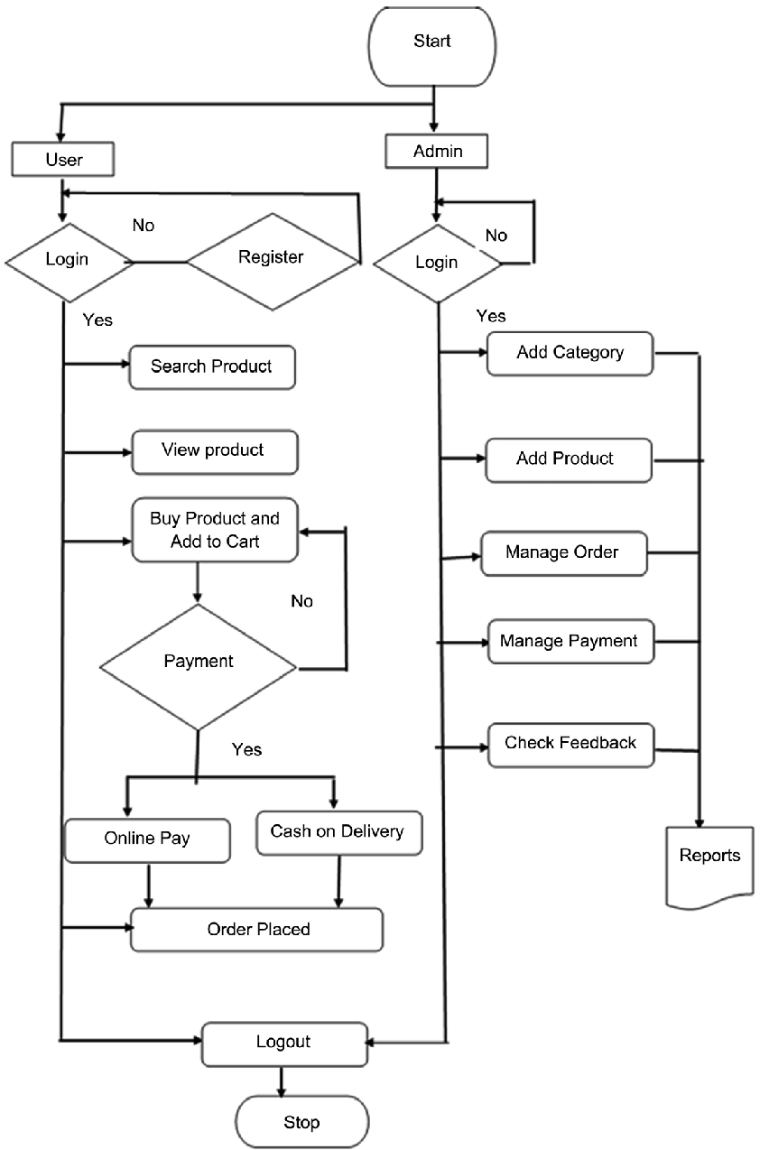

**CHAPTER-4**

**MODULE DESCRIPTION**

* Module 1: Used for managing the Food Item details.
* Confirm Order Module : Used for managing the details of Confirm Order
* Payment Module: Used for managing the details of Payment.
* Category Management Module: Used for managing the information and details of the Category.
* Customer Module: Used for managing the Customer details
* Order Module: Used for managing the Order informations
* Login Module: Used for managing the login details
* Users Module Used for managing the users of the system

**CHAPTER-5**

REQUIREMENT GATHERING  
  
• Requirements gathering is done in order to understand the problem the software system is to solve.  
  
• Problem Understanding or Analysis and Requirement Specification. In problem analysis, the aim is to understand the problem and its context, and the requirements of the new system that is to be developed.  
  
Once the problem is analyzed and essentials understood, the requirements must be specified in the requirements specification document.  
  
• The requirement document must specify all functional and performance requirements: the formats of inputs and outputs; and all design constraints that exist due to political, economic, environmental, and security reasons.

**HARDWARE REQUIREMENT**

**CHAPTER-6**

**SAMPLE CODE**

**LOGIN PAGE:**

**HOME PAGE:**

**MENU PAGE:**

**ABOUT PAGE:**

**CONTACT PAGE:**

**QR CODE:**

**SIGN UP PAGE:**

**DATABASE PAGE:**

**SAMPLE IMAGES**

**LOGIN PAGE:**

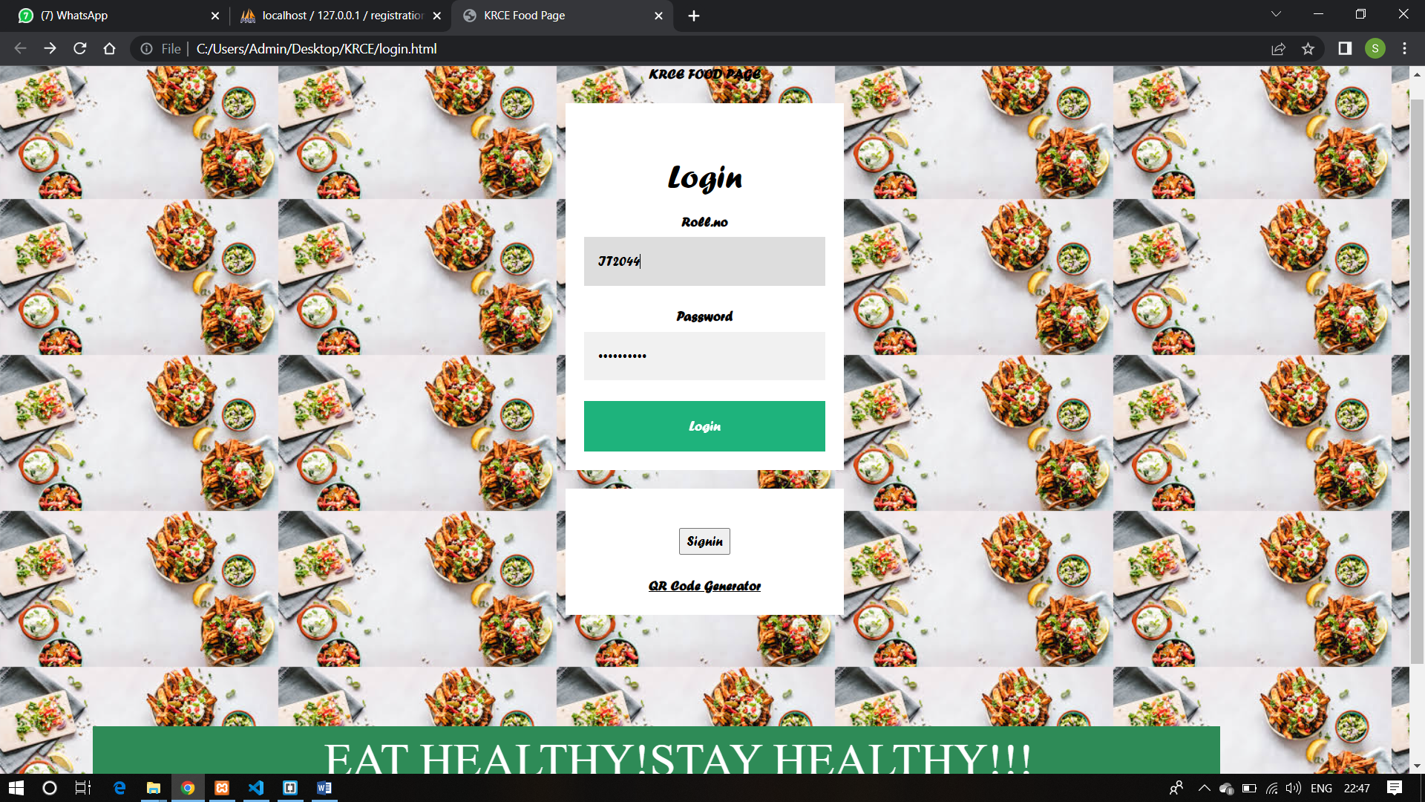

**SIGNUP PAGE:**

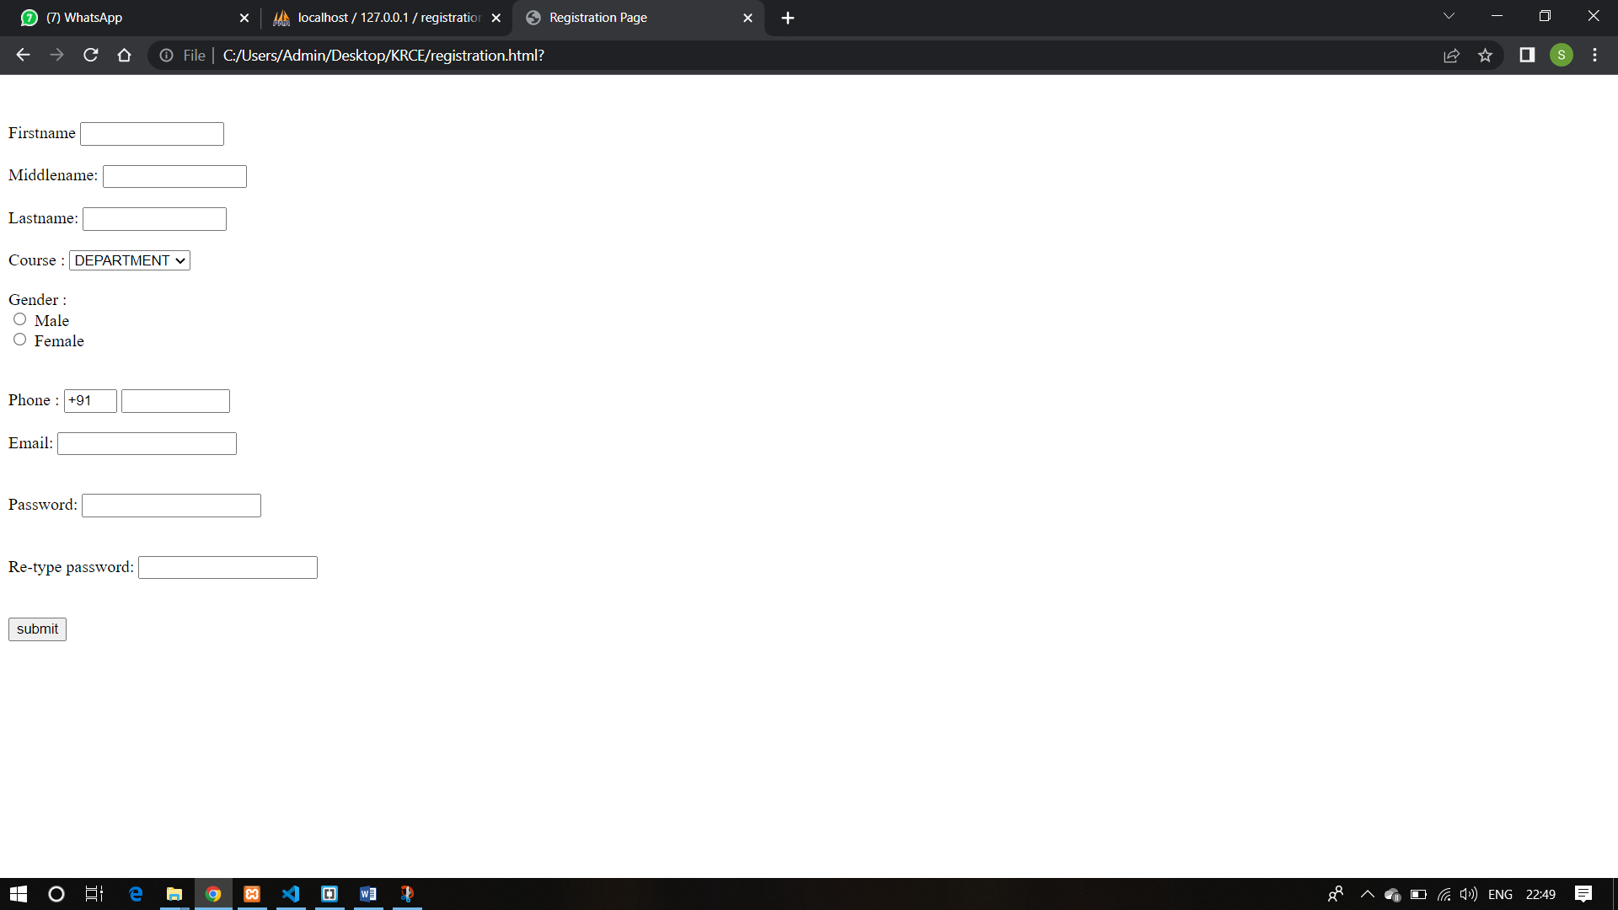

**QRCODE PAGE:**

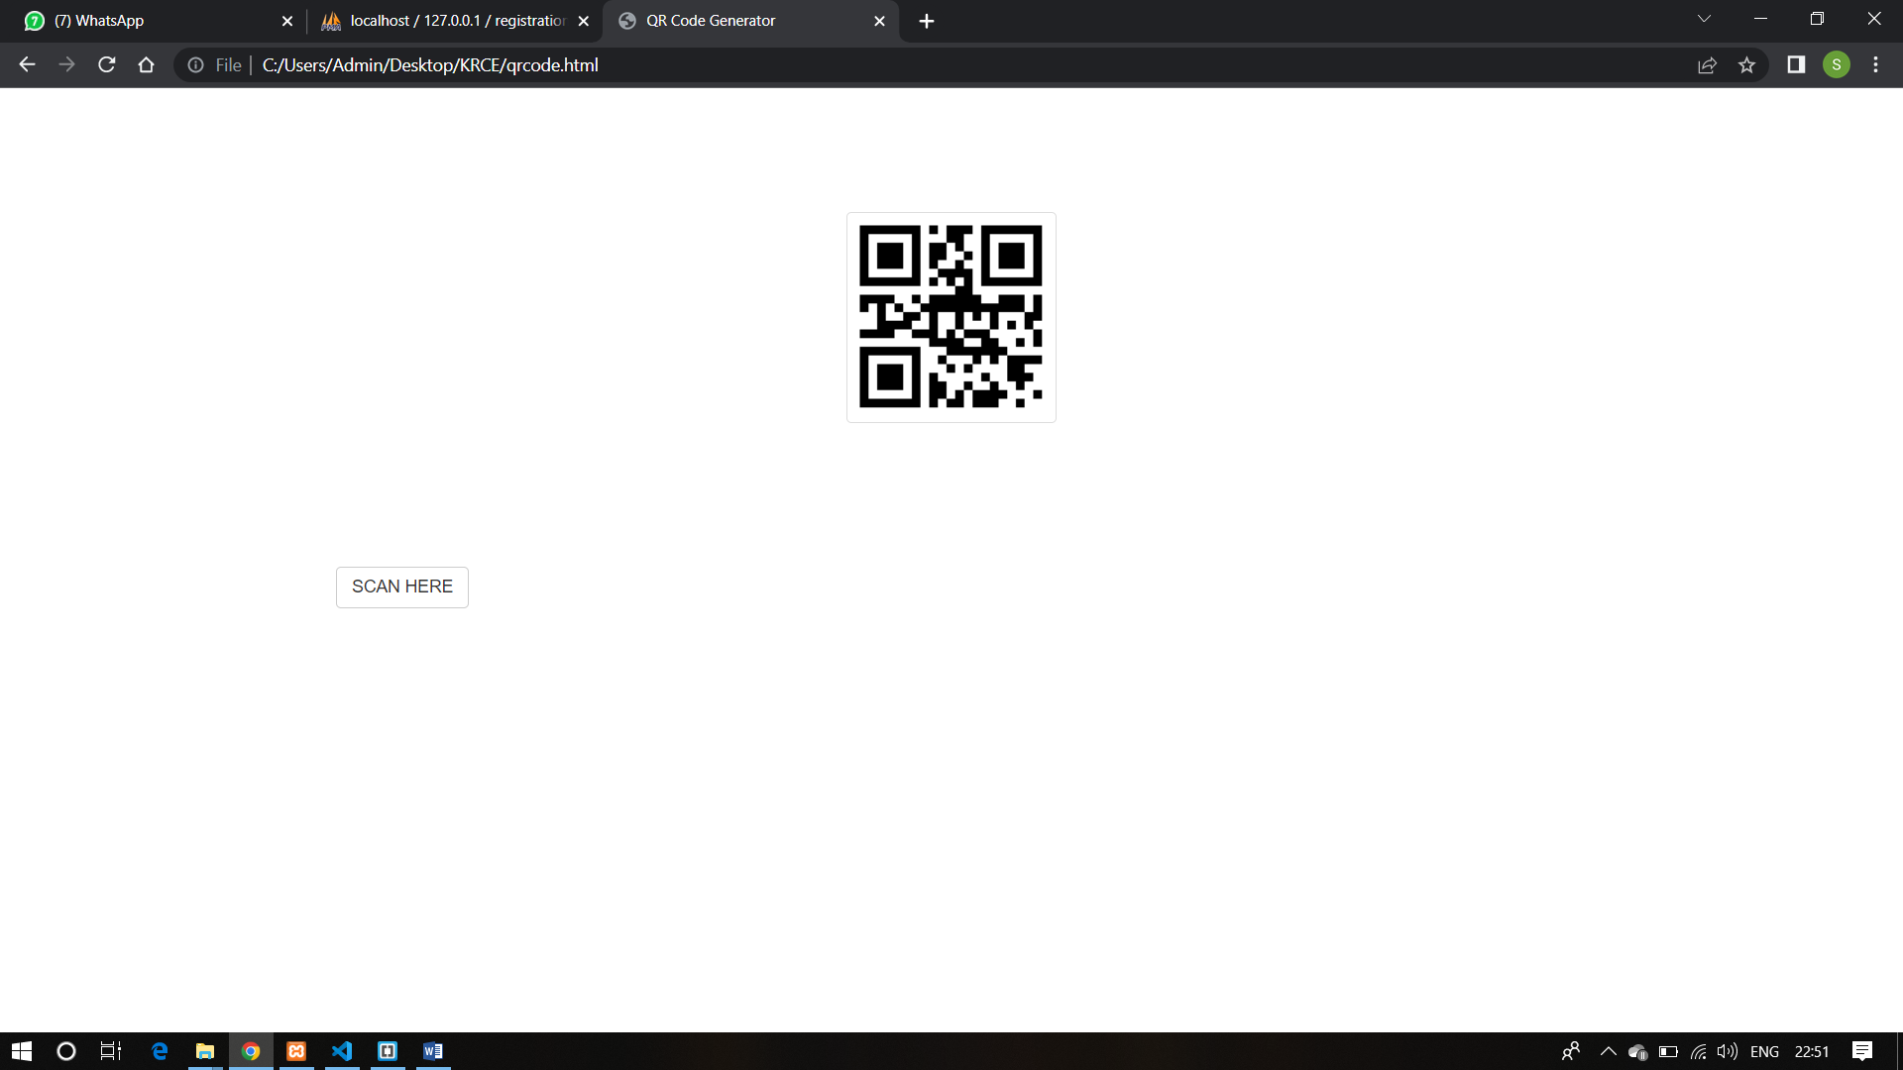

**HOME PAGE:**

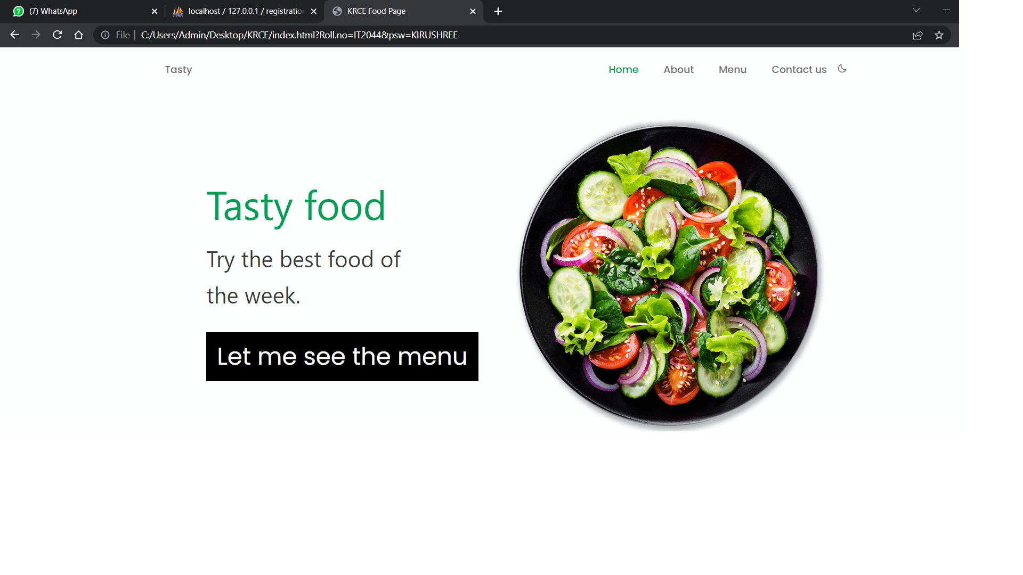

**MENU PAGE:**

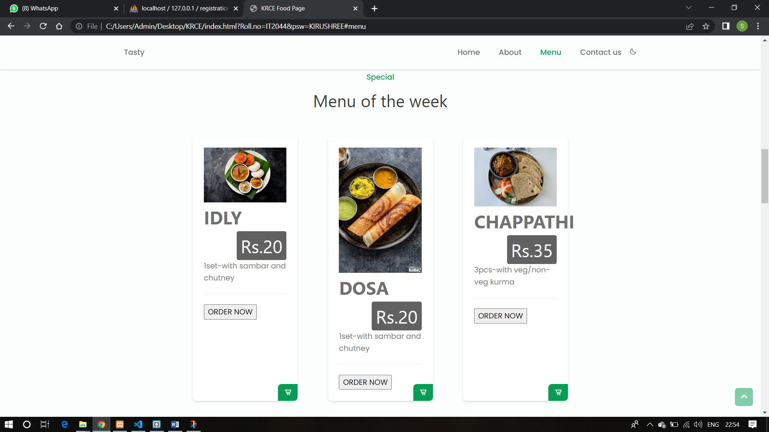

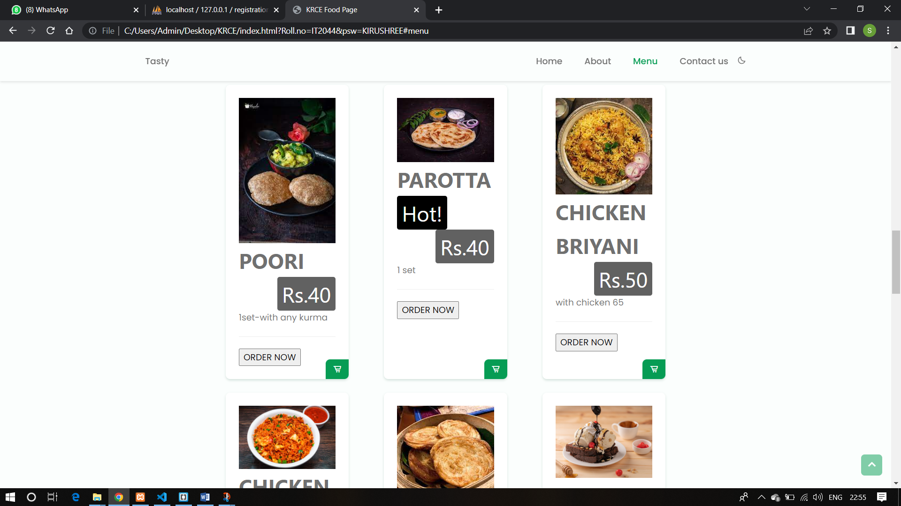

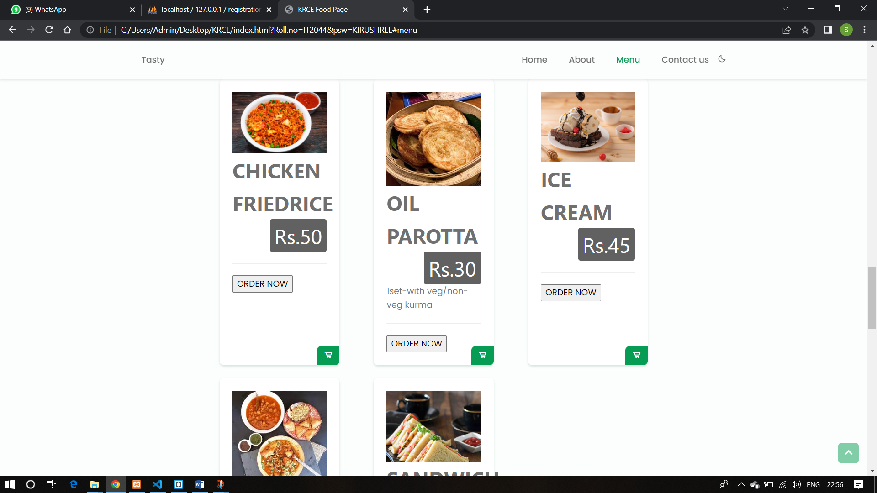

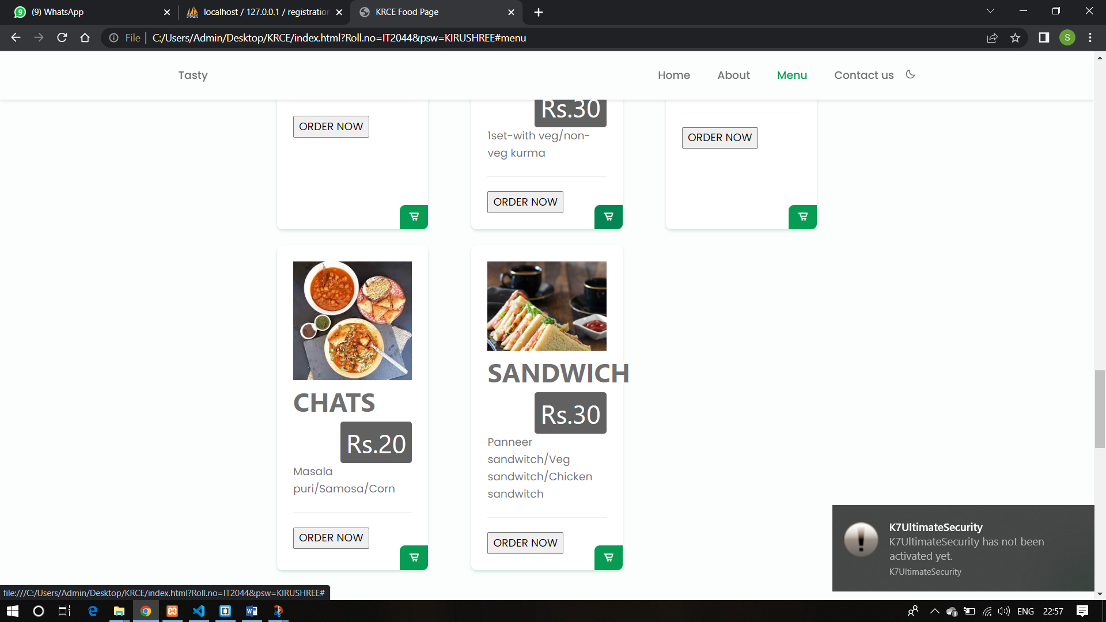

**ABOUT PAGE:**

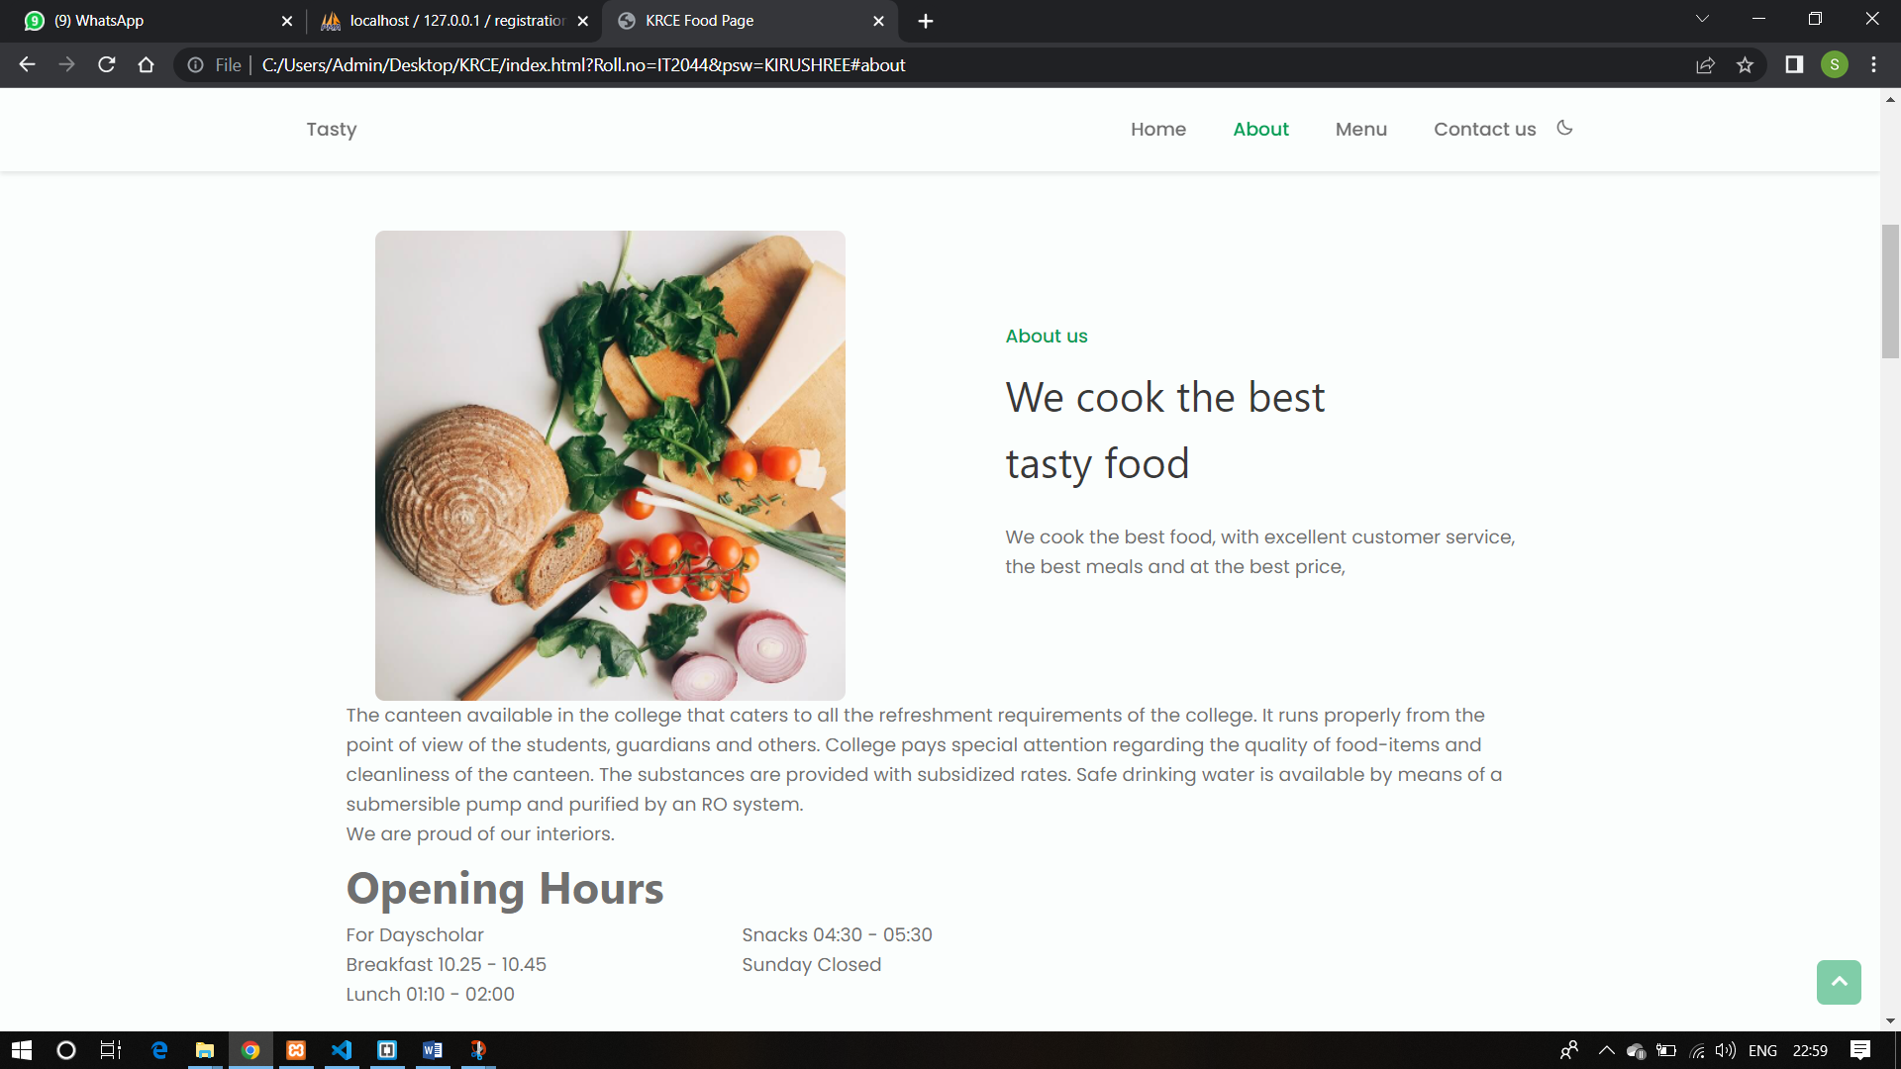

**CONTACT US:**

